Hi,
Just to share this USDCHF trade today.
Was watching this since last week, and waited for a good high probability setup. Thought this maybe it. So let market decide.
Feel free to comment and discuss.
Thank you.
regards,
Attached Image (click to enlarge)
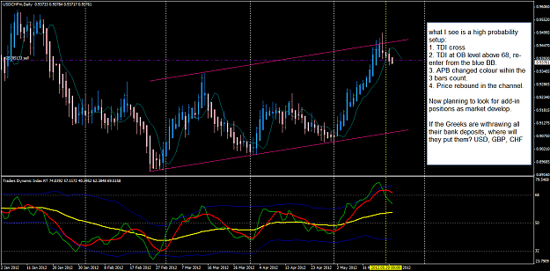

Quoting binnie
GU signal confirmed on 30min chart. Any feedback from anyone ?
Binnie
Hi,
H4 show HH HL ... so buy is a better idea.
yesterday there was no follow through down to fib-e 127%, and looks like PA is retracement back into last week range.
but how will you get a better entry price now?
regards,
Attached Image (click to enlarge)
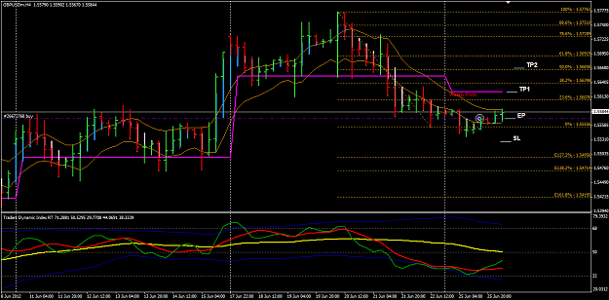

Here is an important post where your will find pdf of BigE' posts and comments:
http://www.forexfactory.com/showthre...75#post5463775
whether it is 5EMA or 5SMA, there is little difference.
whether you use shift +2 or shift+3 will also not make a lot of difference.
as BigE had mentioned many times, he put more weight on TDI over the 5EMA.
you can also enter when the HA is below 5EMA so long there is a TDI cross.
It is your knowledge in Price Action and how you apply that in your trading that will make a huge difference whether you can achieve and maintain consistent trade results.
Regards,
Attached Image (click to enlarge)
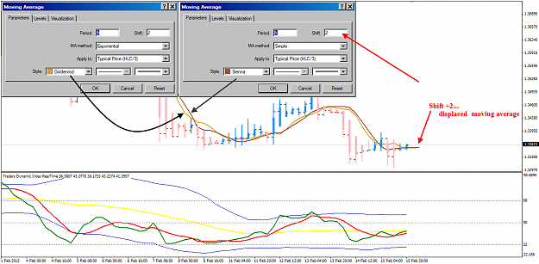

Hi BB,
Those are Fibonacci levels using the Previous Week High Low range. It is not a holy grail, but I use those fib levels as intra-week support and resistance when I trade H4.
But CONFLUENCE of support and resistance is important for example: W and D OHLC, BRN, RN, Fib levels, Pivots and historical support and resistance.
Another H4 trade example occured yesterday.
Trade Well.
Attached Image (click to enlarge)

To all TMS followers:
Here is classic TMS H4 setup taught by the late FF member Eelfranz fondly known as Big E.
This must be supported by a higher TF candlestick pattern, chart patterns and support and resistance. For higher probability trades, the setup must occur at a CONFLUENCE of Support and Resistance for example 50/200EMAs, RN, BRN, Fibo levels, Pivots levels. Do your own back-testing and you will learn the occurences of such setup condition and the pips run for each of the setups.
Also, many are still puzzled with the clock face 12-2 and 4-6 when we make reference to the TDI PL Green line. Hope this answer what it mean. It is Price Action which we must read on our charts and that is the key to have more winning trades.
Trade Well!
Attached Image (click to enlarge)
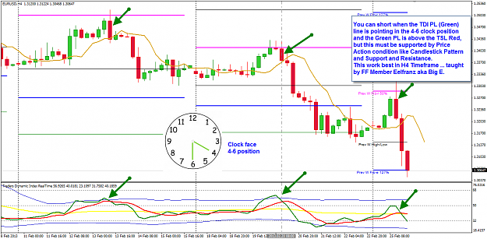

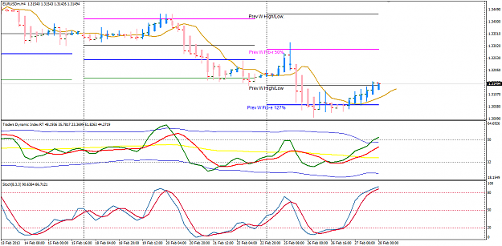
Page 782..
Hi folks,
Big E talked about TDI 12-2 and 4-6 entries. I know some new traders using this TDI thingy is not sure what 12-2 and 4-6 means.
So here is AU H4 chart .. "a picture is worth more than a thousand words".
Today beware of this aussie, big news ahead in few hours. The smart money will get you.
Trade Well.
Attached Image (click to enlarge)
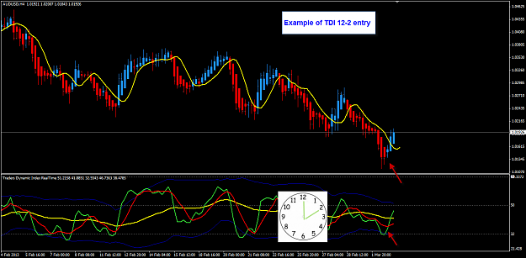
Page 786
Price Action is key in trading. See attached chart.
You maybe using the TDI Red Green from this thread, right?
I use the TDI Realtime version which may explain some small difference.
Attached Image
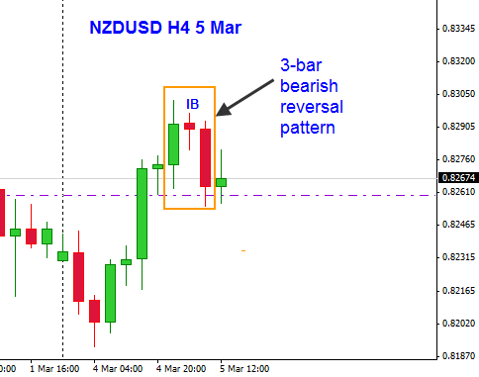
787

I like this one ... "Put on your thinking caps"...very much, it reminds me of DeBono teaching.
I put on all 6 thinking hats when I trade or rather I switch hats each time the market ticks and one H4 bar closes.
Attached Image (click to enlarge)
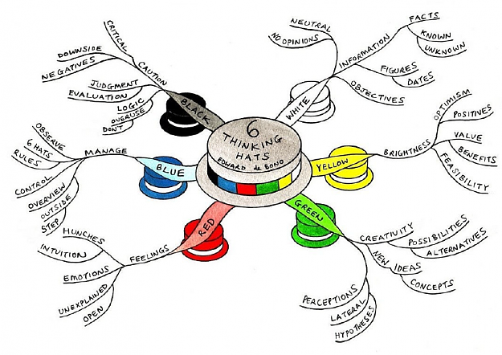
792 pg
Hi Nelly,
attached is s simple explanation what I meant by R and R-Multiple trade management.
This is NZDUSD , I missed the entry and today I am not trading, just went out to watch the waves.
Cheers!
Attached Image (click to enlarge)
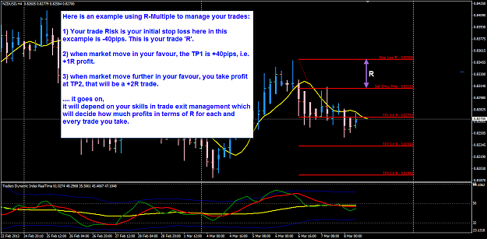

My GBPNZD trade closed.
Price not moving and sitting on RN 1.8050 also yesterday low.
Now back to waiting for the next good setup to catch the next wave.
Attached Image (click to enlarge)
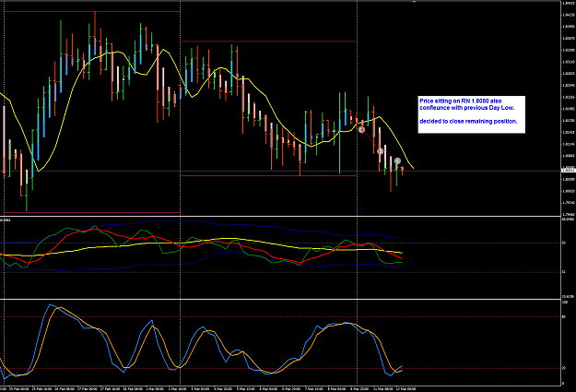

Quoting emmanuel7788
GBPNZD H4
Take look at this pair, it just pullback from the BRN 1.8000.... is that FEAR?
week 9, it rallied from that level.
Here is my chart for a Big Picture view and plan your next trade.
Attached Image (click to enlarge)

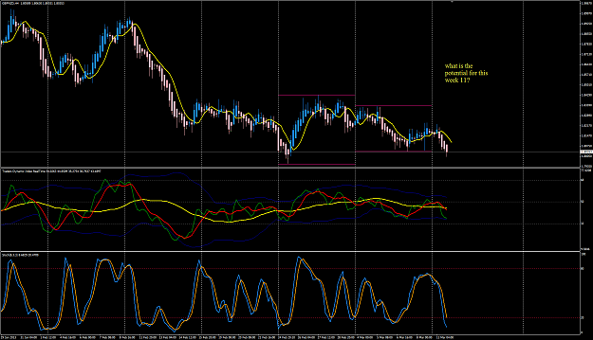

My GBPNZD trade:
SL 100pips
TP1 50pips, + BE trade.
TP2 150pips
This is a CT trade as the H4 trend is still bearish. Maybe intra-week correction.
Attached Image (click to enlarge)
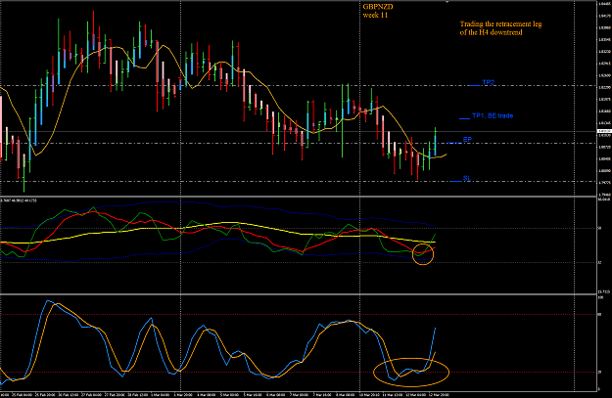

EA and GA week 11 H4 potential setups.
Look for aussie weakness....!
Attached Images (click to enlarge)
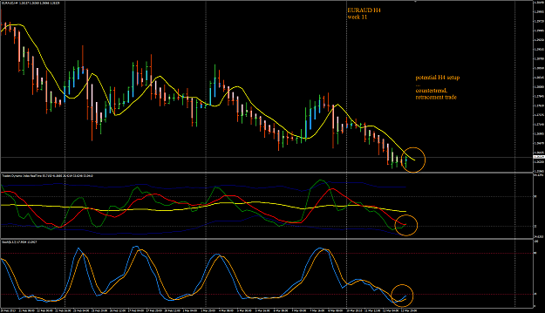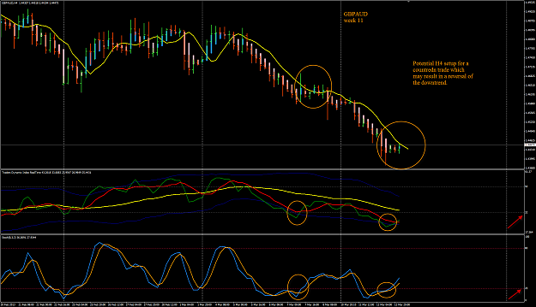

AU week 11 13 Mar Trade NYO:
Here is my trade entry for AU.
Right at the Fib-r 50% retracement of the last H4 where the TDI crossed.
SL -50pips
TP2 +75pips
Attached Image (click to enlarge)

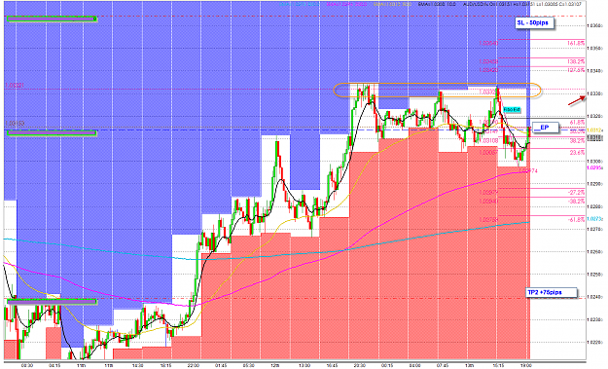

AU 13 Mar H4 NYO:
Looks decent with TDI cross and Stock confirm.
PA show a bearish engulfing candle and DBHLC.
Attached Image (click to enlarge)
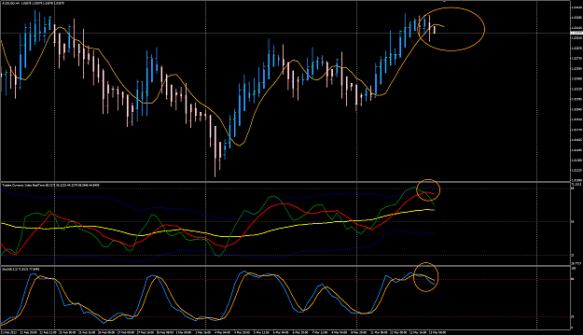
807 pg

GBPAUD 13 Mar H4 Trade
Took the entry when LO.
Exited one position +50pips , now BE remaining.
Attached Image (click to enlarge)
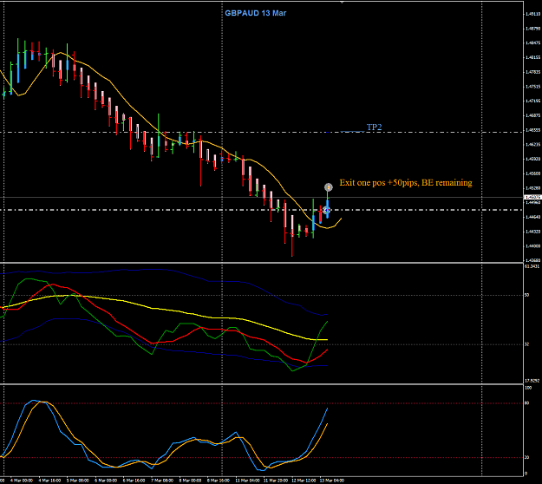

EJ H4 example - how to get a better price entry.
There are times when we missed the first HA entry candle and waited for the 2nd HA to close. But when 2nd HA close too far away, it is always better to look in the lower TF like H1 for a retracement to get a better enetry price. This will reduce your inital SL ( R) and a a better position size.
See chart.
Attached Image (click to enlarge)
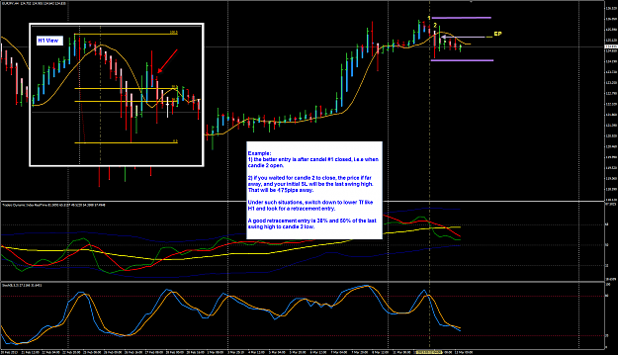

EURAUD week 11 trade closed.
My worst loss for this week.
Attached Image (click to enlarge)
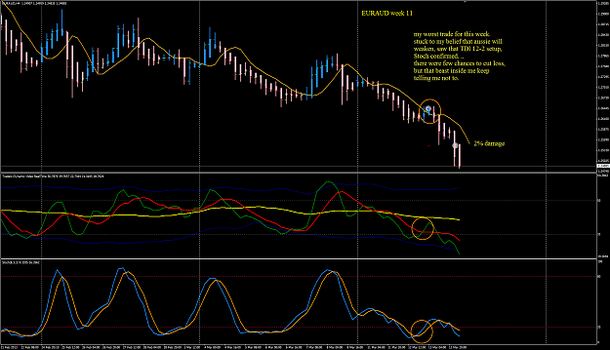

NU week 11 H4 trade:
RBNZ rate announcement, no surprise that it will keep its 2.5% rate. So Sellers just waited like the Bears.
It's 4:25AM my local time, woke up to check if my trade manager manage this trade correctly.
And it did just what I set it to do.
Partial exit TP1 +50pips, BE remaining trade to run.
Another BEAR feeding this week.
Attached Images (click to enlarge)
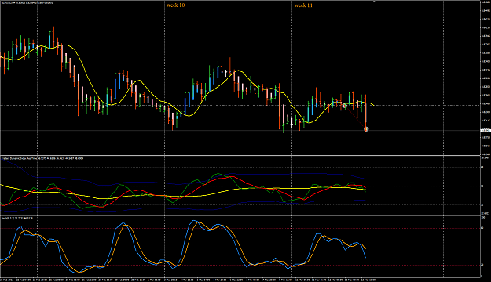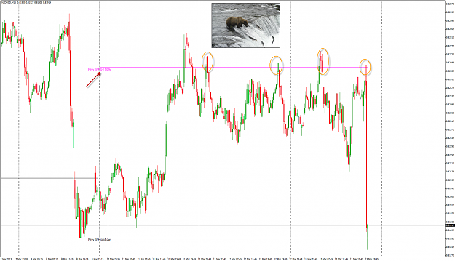

Bears wait upstream for the salmons to come to them. That is what we all Bears must do.
Sorry this chart is naked and not TMS.
Attached Image (click to enlarge)
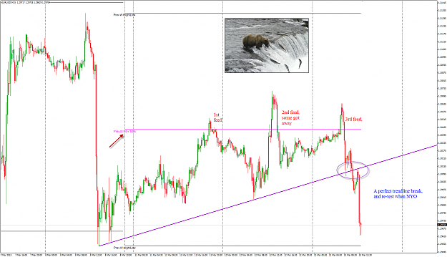

Ok, below is my chart to explain the Pop Gun setup and trigger.
I know we discuss mostly TMS H4 trading here, but there are some M15 lovers here too.
This is specially for you.
This is trading the Breakouts.... after long period of price consolidation. You have multiple 4-hour period to spot this sort of market type. You do not need to keep looking at your charts until your eyes pop out of their sockets. Just look once every 4-hours. When you see what you look for, then you glue onto your computer screen for a few hours.
Attached Image (click to enlarge)
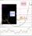
Page 810

Always Know which of the Market Trend you are trading:
Attached Image (click to enlarge)
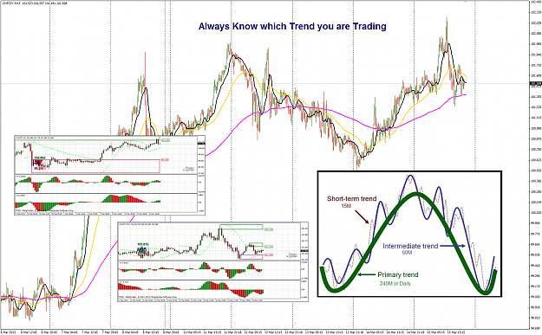
Page 812

GBPCHF week 11 15 Mar
A very interesting consolidation H4 candlestick pattern. But can this be a major reversal of this week uptrend?
Attached Image (click to enlarge)
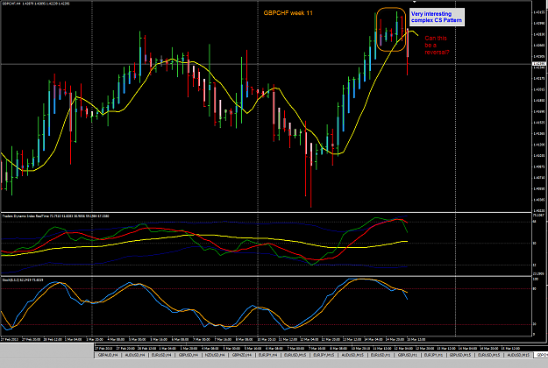

Well, today I can safely say that the H4 downtrend has ended and the double bottom form confirmed the bullish reversal for GBPAUD.
My last remaining position still running. Will keep this over the weekend if it survive the NY session later. If it survives, next week look for pullback add positions...." Buy on Dip"
Attached Image (click to enlarge)
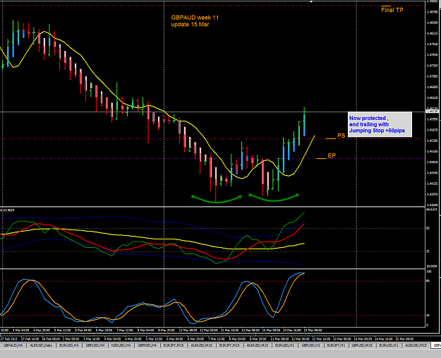

I love trading H4 pin bar with H1 price momentun in it ...
Attached Image (click to enlarge)

